Security Protocols
Lab 6: 3rd Party Authentication Systems
  - Author: Antonie Șoga

OAuth
OAuth is an open standard for access delegation, commonly used as a way for Internet users to grant websites or applications access to their information on other websites but without giving them the passwords.
This mechanism is used by companies such as Google, Facebook, Microsoft and Twitter to permit the users to share information about their accounts with third party applications or websites.
Generally, OAuth provides to clients a "secure delegated access" to server resources on behalf of a resource owner. It specifies a process for resource owners to authorize third-party access to their server resources without sharing their credentials. Designed specifically to work with Hypertext Transfer Protocol (HTTP), OAuth essentially allows access tokens to be issued to third-party clients by an authorization server, with the approval of the resource owner. The third party then uses the access token to access the protected resources hosted by the resource server.

Executive Summary
This lab demonstrates the implementation of a secure authentication system using Google Sign-In, leveraging the OAuth 2.0 and OpenID Connect (OIDC) protocols.
The objective was to move away from traditional, risky password-based authentication (where the application stores user credentials) to a Federated Identity model. In this model, Google acts as the Identity Provider (IdP), verifying the user's identity and issuing a secure token to our application (the Relying Party).

Theoretical Framework

OAuth 2.0 vs. OpenID Connect
While often used together, these protocols serve different purposes:
- OAuth 2.0 is strictly for Authorization. It allows a user to grant a third-party application access to their resources (like their Google Drive or Calendar) without sharing their password. It is like giving a valet a key that only opens the car door but doesn't start the engine.
- OpenID Connect (OIDC) is a layer built on top of OAuth 2.0 specifically for Authentication. It allows the application to verify who the user is. It provides an ID Token (JWT) containing user profile information.

JSON Web Tokens (JWT)
The core artifact received from Google in this lab is the credential, which is a JWT. A JWT is a compact, URL-safe means of representing claims to be transferred between two parties. It consists of three parts:
- Header: Algorithm and token type.
- Payload: Data (claims) about the user (email, name, picture, expiration time).
- Signature: Cryptographic signature verifying the token hasn't been tampered with.

Implementation Details
The application was built as a Single Page Application (SPA) with a "Security Terminal" aesthetic.

Environmental Configuration (Addressing Task 1)
We identified that the browser's file:// protocol is not a supported origin for Google's OAuth 2.0 service due to security restrictions. To resolve this (addressing Task 1 of the lab requirements), we deployed a local HTTP server using Python:
python3 -m http.server 8080
We then registered http://localhost:8080 as an Authorized Javascript Origin in the Google Cloud Console, which allowed the authentication flow to proceed.

Authorization Request (g_id_onload) & Library Fix
We utilized the Google Identity Services (GIS) library. During implementation, we discovered a discrepancy in the lab manual: it referenced the deprecated platform.js library while using the modern g_id_onload HTML API.

We corrected this by implementing the modern GIS library source:
<script src="https://accounts.google.com/gsi/client" async defer></script>
The configuration was then handled via the g_id_onload HTML element:
<div id="g_id_onload"
data-client_id="YOUR_CLIENT_ID..."
data-callback="handleCredentialResponse"
data-auto_prompt="false">
</div>
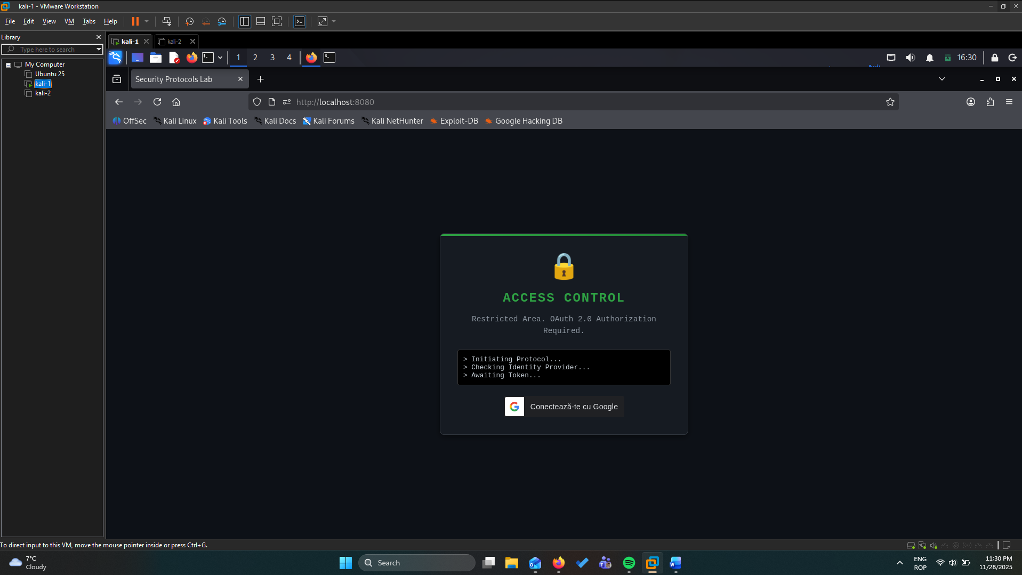
Figure 1: The secure login terminal implementing the Google Sign-In button.
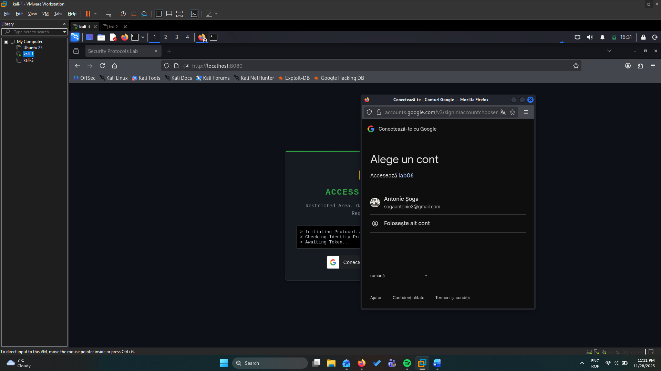
Figure 2: Google Authentication.

Token Parsing & Session Management
Unlike traditional server-side sessions, this implementation uses a client-side approach:
- Decoding: We implemented a parseJwt function to base64-decode the payload of the JWT. This allows us to extract the user's name (given_name) and email without making a second API call.
- Persistence: To simulate a persistent login session, we utilized the browser's localStorage:
- localStorage.setItem('googleUser', JSON.stringify(responsePayload));
On page load, the script checks for this item. If found, it bypasses the login screen, effectively maintaining the user's "logged in" state across page refreshes.

Token Revocation (Logout)
Simply deleting the local data isn't enough for a true secure logout in an OAuth context. We implemented Revocation:
google.accounts.id.revoke(user.email, done => { ... });
This API call tells Google's servers that the specific grant for this application is no longer valid. This ensures that even if a token were stolen effectively, the consent link is broken server-side.
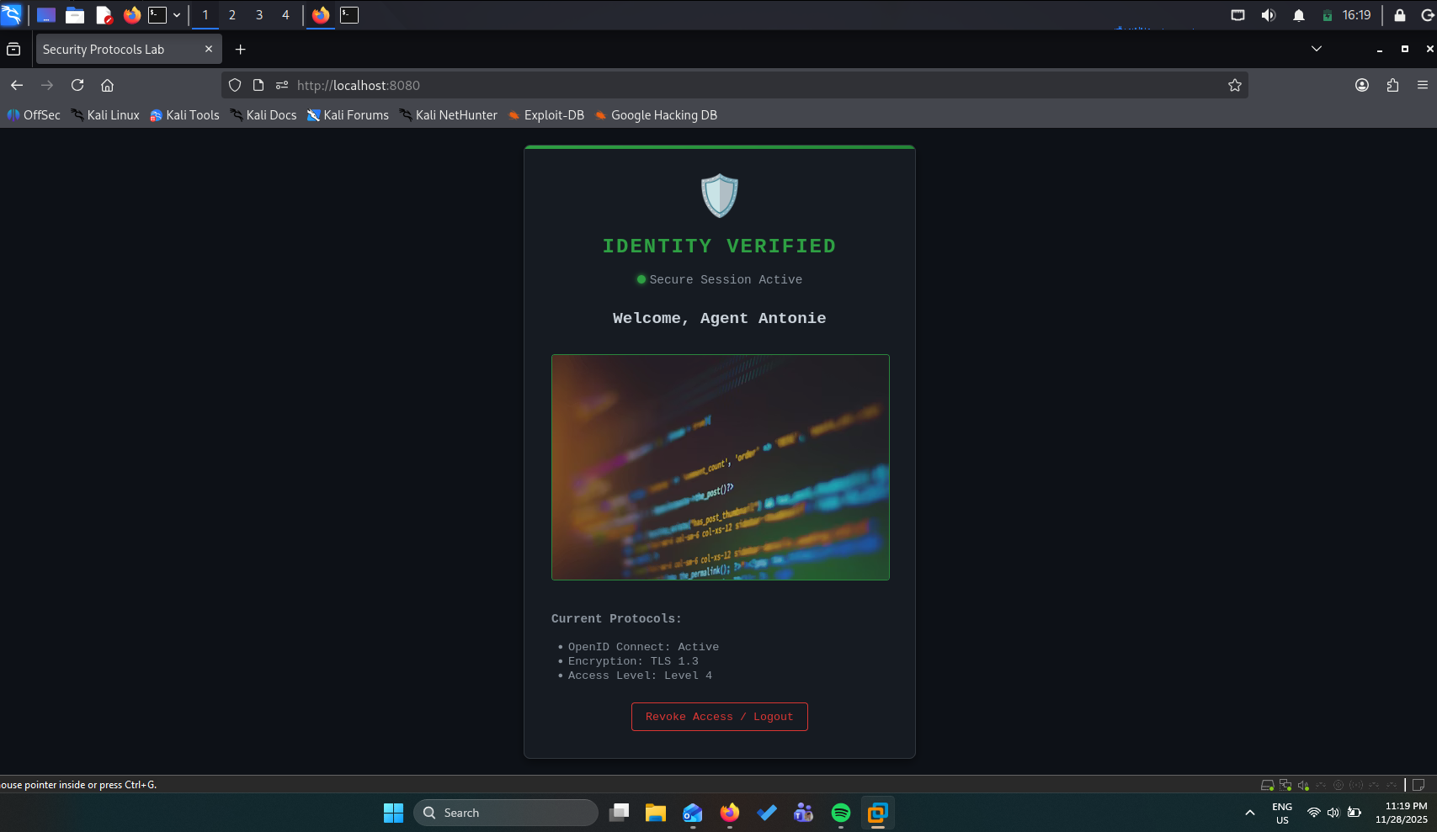
Figure 3: The authenticated state showing decoded user information.

Security Analysis

Advantages of this Approach
- Reduced Attack Surface: We do not store or handle passwords. This eliminates the risk of password database leaks, SQL injection attacks on login forms, and weak user passwords.
- Phishing Resistance: The actual login happens on accounts.google.com. A user trained to look for the Google URL is less likely to enter credentials into a fake login form hosted by our app.
- Standardization: Using OIDC ensures we are following industry-standard handshake protocols rather than inventing our own (potentially flawed) crypto.

Limitations & Future Improvements
- Client-Side Validation: Currently, the JWT is decoded on the client side for display purposes. In a production environment, this token must be sent to a backend server and verified cryptographically (checking the signature against Google's public keys) to prevent token forgery.
- XSS Vulnerability: Storing tokens in localStorage makes them accessible to JavaScript. If the site suffers from a Cross-Site Scripting (XSS) vulnerability, an attacker could steal the session. A more secure approach for high-value apps is using HttpOnly cookies.

Conclusion
The lab successfully demonstrated the integration of third-party authentication. By offloading identity management to Google, we created a user-friendly and secure entry point to the application, fulfilling the requirements of modern web security protocols.

